 

# Placement Empowerment Program

***Cloud Computing and DevOps Centre***

Back Up and Restore a Cloud Instance : Take a snapshot of your cloud VM. Terminate the VM and restore it from the snapshot.

Name: BHUVANA K

Department: CSE



# Introduction

In today's cloud-driven world, ensuring data availability and reliability is paramount. This Proof of Concept (POC) focuses on the **Backup and Restore** process for a cloud instance, showcasing how critical data can be safeguarded and restored efficiently in AWS. By taking a snapshot, terminating the instance, and restoring it from the snapshot, this POC demonstrates the ease and reliability of AWS Elastic Block Store (EBS).

# Overview

This POC involves working with Amazon Web Services (AWS) to perform the following tasks:

1. Launching an EC2 instance.
2. Creating an EBS snapshot of the instance's volume to back up its data.
3. Terminating the instance to simulate a failure or cost-saving scenario.
4. Restoring the instance using the snapshot by creating a new volume and attaching it to a new EC2 instance.

The step-by-step approach ensures no unnecessary charges while maintaining data integrity and availability.

# Objective

The objective of this POC is to:

1. Demonstrate the process of creating and managing backups in AWS.
2. Explore the capabilities of EBS snapshots for disaster recovery.
3. Understand how to restore a terminated instance and verify data integrity.
4. Highlight cost-saving techniques using AWS Free Tier while ensuring operational readiness.

# Importance

1. **Disaster Recovery:** Ensures that critical data can be restored quickly in case of an unexpected failure.
2. **Cost Optimization:** Demonstrates terminating unused instances and restoring them only when required.
3. **Scalability and Flexibility:** Showcases AWS's ability to manage snapshots and volumes across regions and availability zones.
4. **Practical Knowledge:** Provides hands-on experience in working with EC2, EBS, and snapshot-based recovery processes.

# Step-by-Step Overview

## Step 1:

* 1. Go to [AWS Management Console](https://aws.amazon.com/console/).
  2. Enter your username and password to log in.

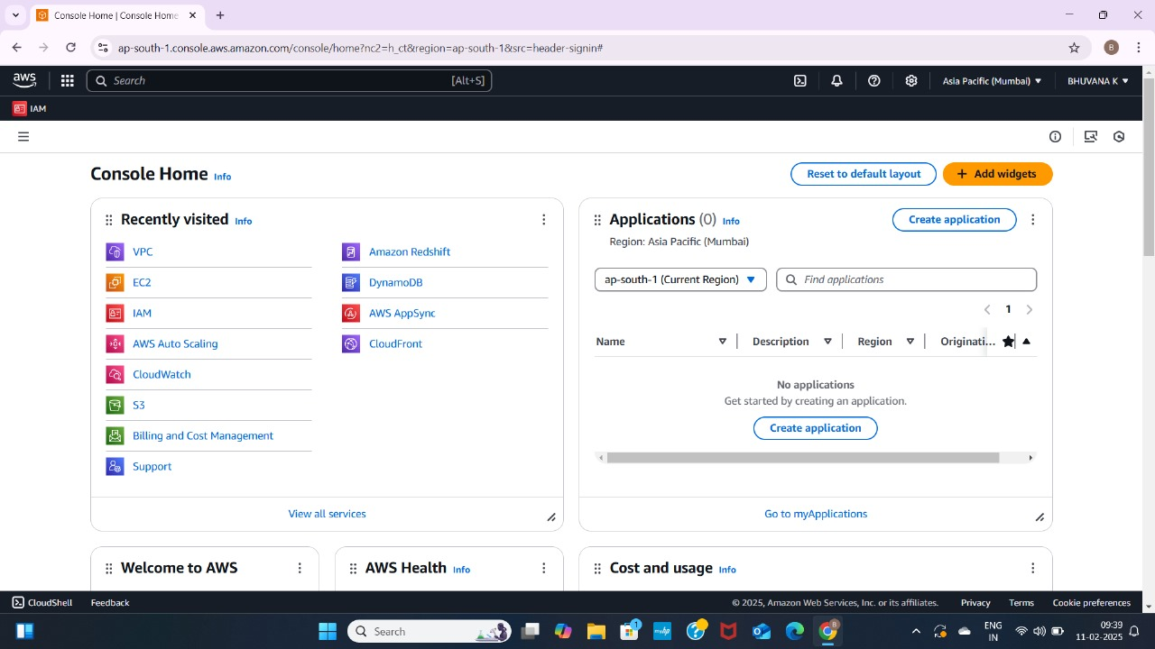

## Step 2:

Launch an Ec2 instance.

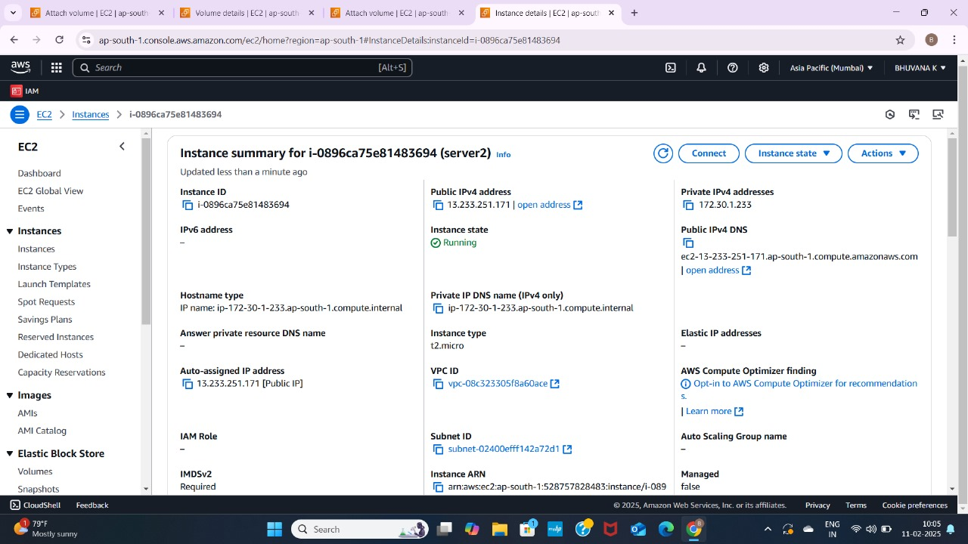

## Step 3:

To create a new EBS volume in AWS, go to the EC2 Dashboard in the AWS Management Console by selecting **EC2** from the Services menu. In the left-hand menu, under **Elastic Block Store**, click on **Volumes**, then click the **Create Volume** button. Select **General Purpose SSD (gp3)** for the volume type, set the size (e.g., 8 GiB, within Free Tier limits), and choose the availability zone that matches your EC2 instance (e.g., us-south-1b). Leave the other options as default, then click **Create Volume**. Be sure to note the Volume ID for future reference.

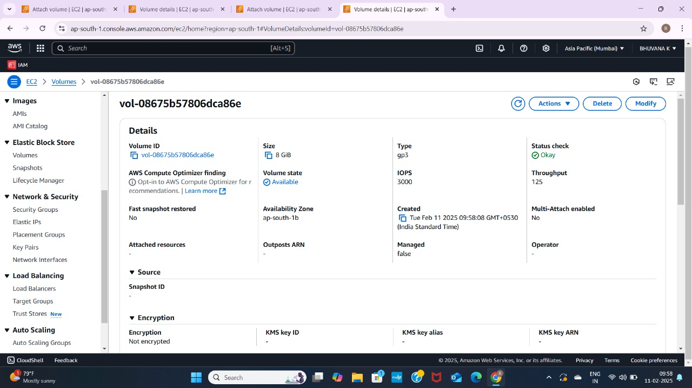

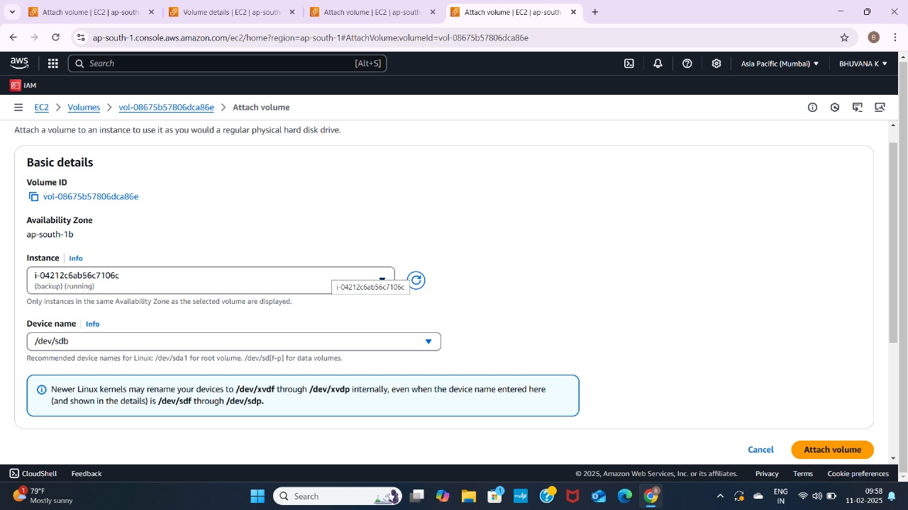

## Step 4:

To create a snapshot of your EBS volume, navigate to the EC2 Dashboard in the AWS Management Console and click on **Volumes** under the **Elastic Block Store** section. Locate the volume attached to your instance (it should match the instance name or ID), select it, then click **Actions** > **Create Snapshot**. Add a meaningful description (e.g., "backup on feb11”)and click **Create Snapshot**. To monitor its status, go to **Snapshots** under Elastic Block Store in the left menu and wait for the status to change to **Completed**.

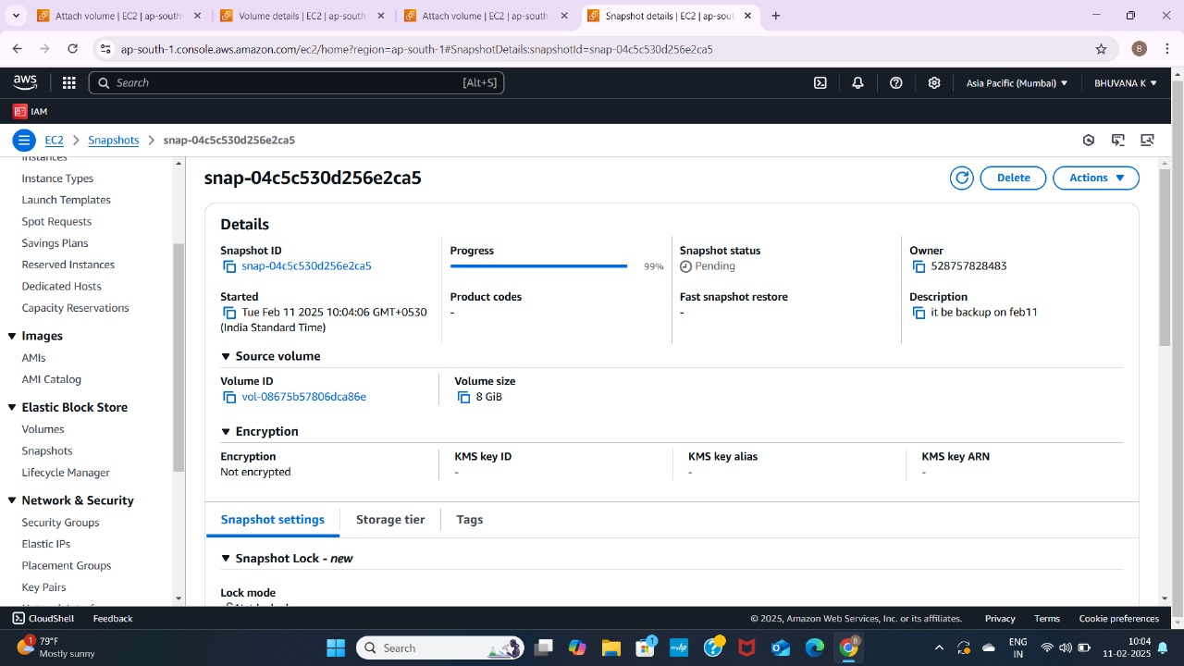

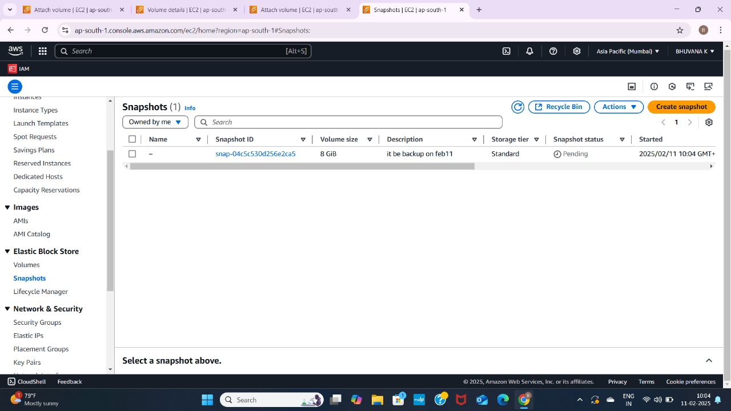

## Step 5:

To terminate an EC2 instance, navigate to the EC2 Dashboard in the AWS Management Console and click on **Instances** under the **Instances** section. Locate the instance you want to terminate, then select it and click **Actions** > **Instance State** > **Terminate Instance**. Confirm the termination by clicking **Terminate**, (Server2 be terminated).





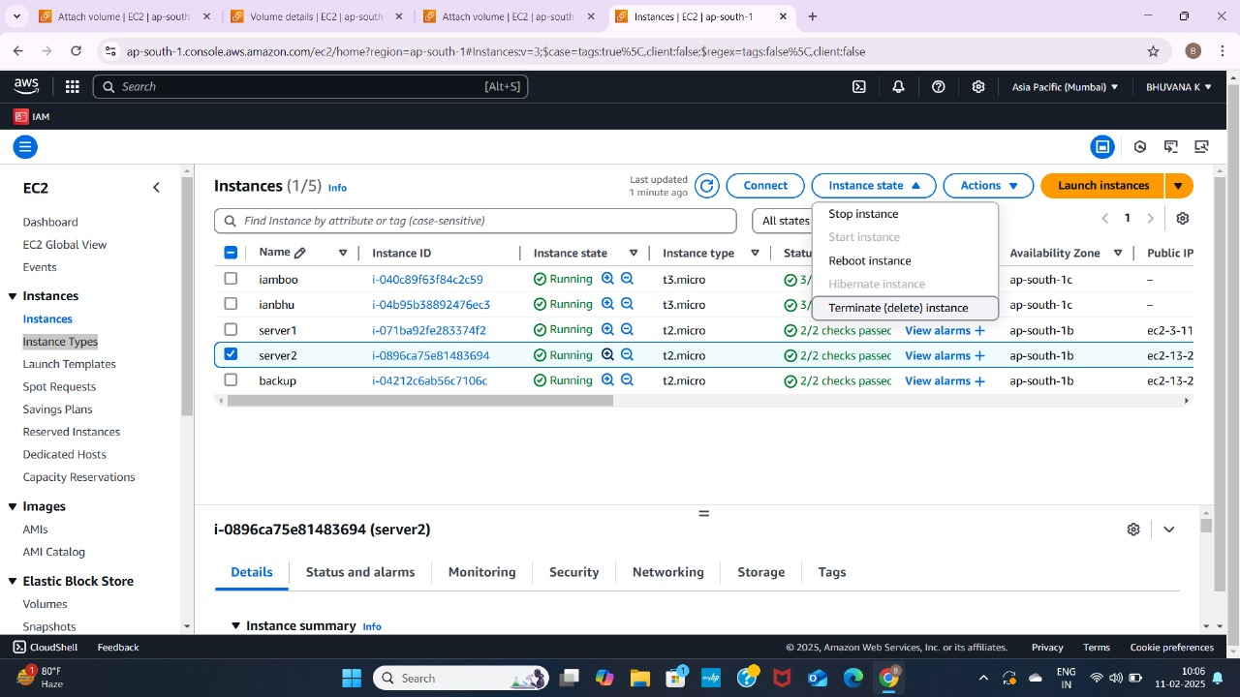

## Step 6:

To create a new volume from the snapshot, go to the EC2 Dashboard and click on **Snapshots** under the **Elastic Block Store** section in the left menu. Select the snapshot you created earlier, then click **Actions** at the top and choose **Create Volume**. In the configuration settings, leave the **Size** as is (it will match the snapshot size) and select the same **Availability Zone** where you want to restore your instance

Finally, click **Create Volume** to complete the process.

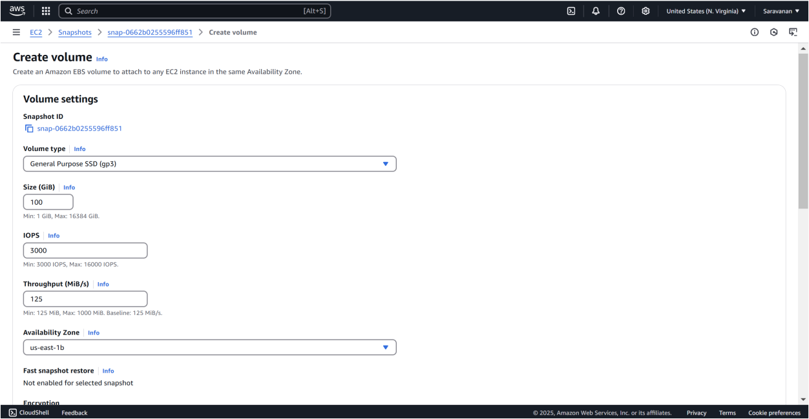

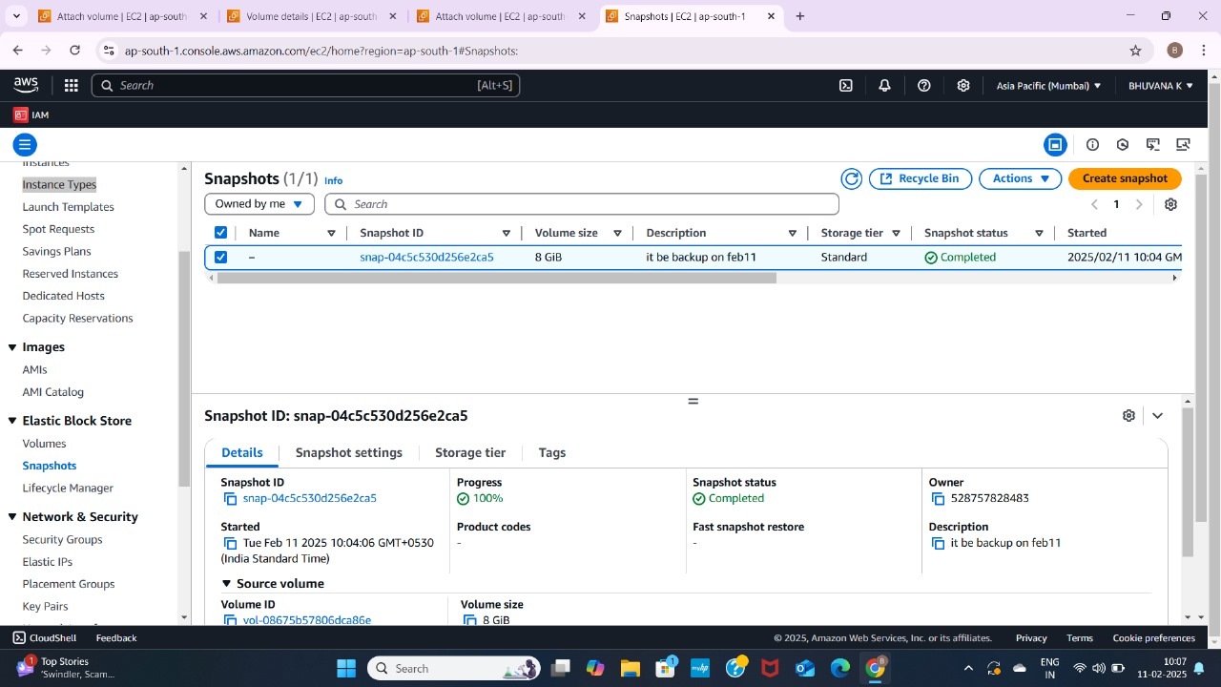

## Step 7:

To launch a new instance, go to the EC2 Dashboard and click **Launch Instances**. Set the name of the new instance) and choose the same AMI (am**azon Linux 2023 Free Tier eligible**) as the original instance. Select **t2.micro** for the instance type (Free Tier eligible). Configure the instance as needed, but skip the storage section for now.

Sample be created a ec2 instance (eg: restore).

After that step 8 be followed.

## Step 8:

To attach the volume to the instance, first, stop the instance temporarily after it is launched by selecting the new instance, then click **Actions** > **Instance State** > **Stop Instance**. Next, go to **Volumes** in the left menu and select the new volume created from the snapshot. Click **Actions** > **Attach Volume**, and in the pop-up window, choose the new instance to attach the volume.

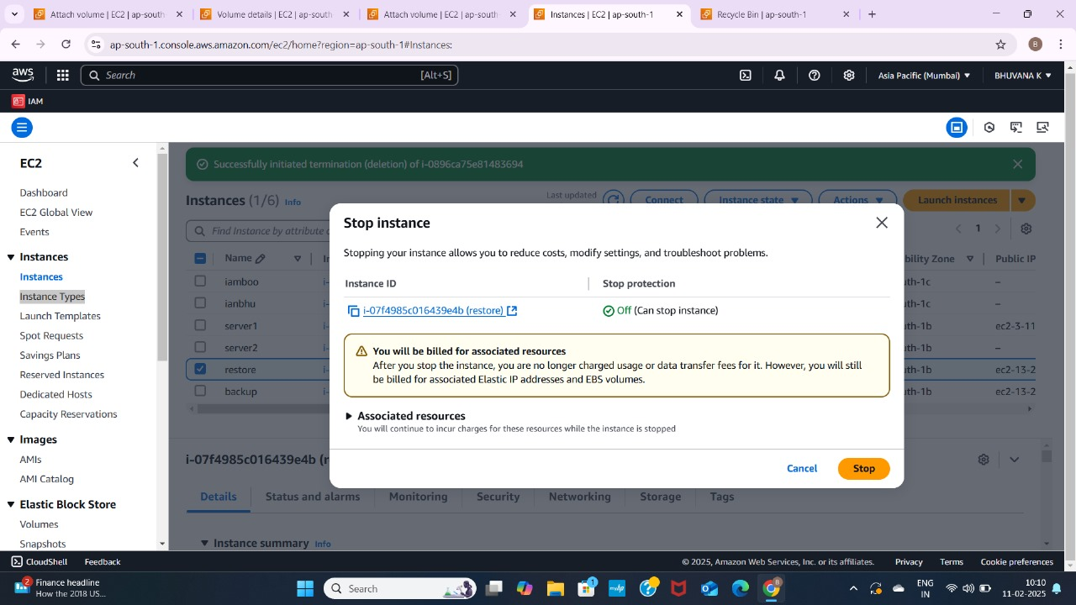

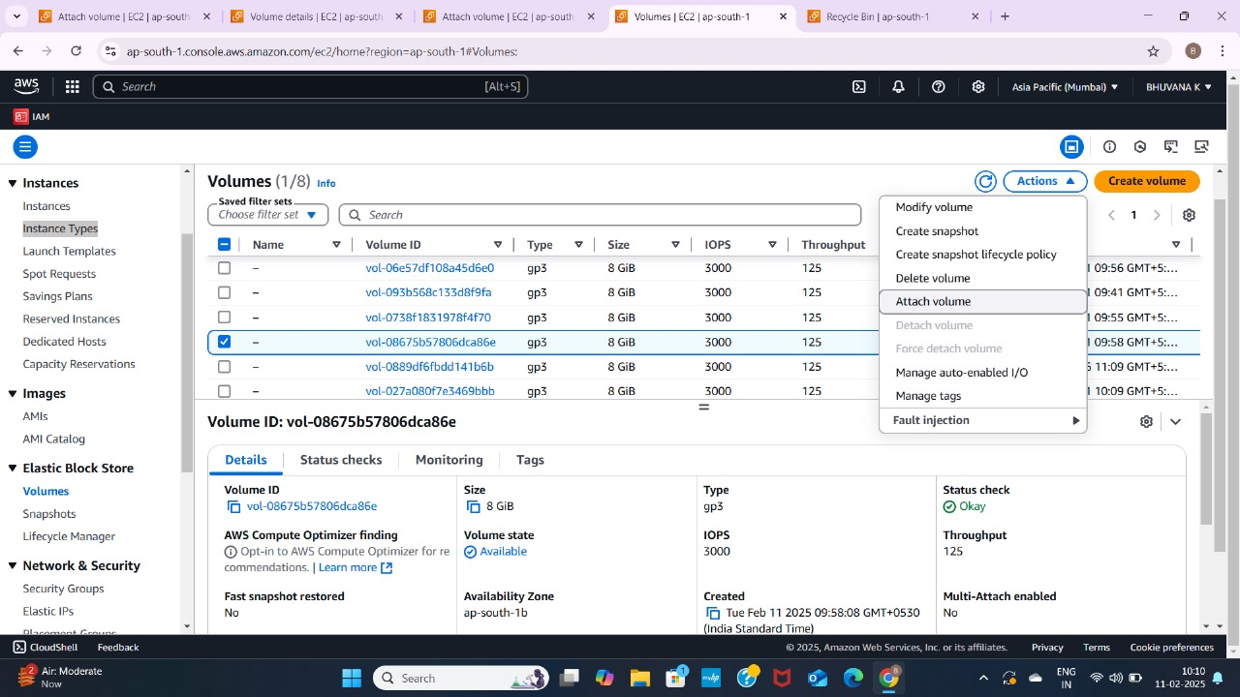

# Verify the Restoration

1. Connect to the instance using SSH or other methods.
2. Check if the files, data, and configurations match the original setup.

POC is **completed** successfully:

1. **Created a Snapshot** of your instance.
2. **Terminated the Instance** to avoid extra charges.
3. **Restored the Instance** using the snapshot by creating a volume and attaching it to a new VM.

# Outcome

By completing this POC of **Back Up and Restore a Cloud Instance**

in AWS, you will:

1. **Create and manage snapshots** of EC2 instances, enabling easy backup of instance data without manual intervention.
2. **Terminate instances** while ensuring that important data remains intact through the backup snapshot.
3. **Restore an instance** from a snapshot by creating a new EBS volume and attaching it to a fresh EC2 instance.
4. **Verify the restoration process**, ensuring data integrity and proper functionality after the instance is restored.
5. **Gain practical knowledge** of AWS services like EC2, EBS snapshots, and how to use them for backup and recovery, which is vital for disaster recovery and business continuity in the cloud.